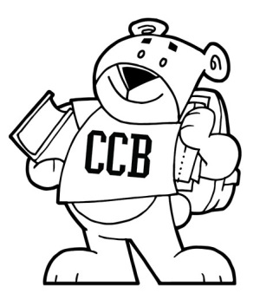
Charles Carroll Barrister Elementary
Monthly Engagement
Monday, October 06, 2025

Meeting Focus and Goals:
- SpEd Instructional Assistance
- ELD Elevation

Session Outcomes – Participants will:

Topic & Time Frame | Presenter
Welcoming Ritual | Ms. Konig –Educational Associate
Elevation  PDP Certification Credits | Ms. Duffy – Educational Associate
Green School Application | Ms. Bainbridge – STEAM Teacher
Supporting Diverse Learners  With Supplemental Aids & Services  Within the Classroom Setting | Ms. Chester – School Success Liaison
Parent Teacher Conferences  Procedures & Protocols | Leadership Team

City Schools Compliance Training Modules
This is a requirement for all district employees.
The following Modules are required:
- Cyber Awareness
- Child Welfare
- Data Privacy & Security
- Navigating the Employee Handbook
- Workplace Safety
- Fair Practices
All Modules should be complete by Wednesday, October 15th

